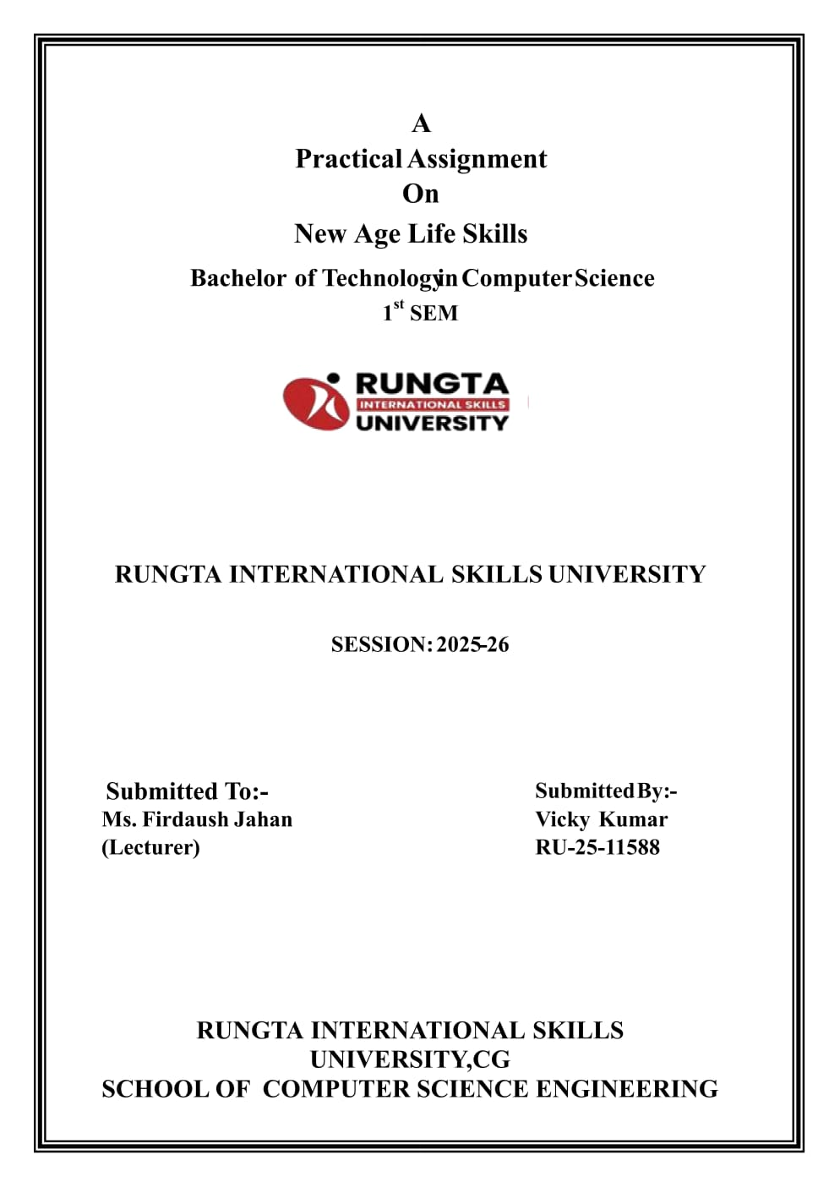 P[PPPPPPPPP

BACHELOR OF COMPUTER APPLICATION (DATA SCIENCE)

Ms. PRIYA DAS

NEHA YADAV

RU-25-10877

BCA(DATA SCIENCE)

BACHELOR OF COMPUTER SCIENCE (BCA)



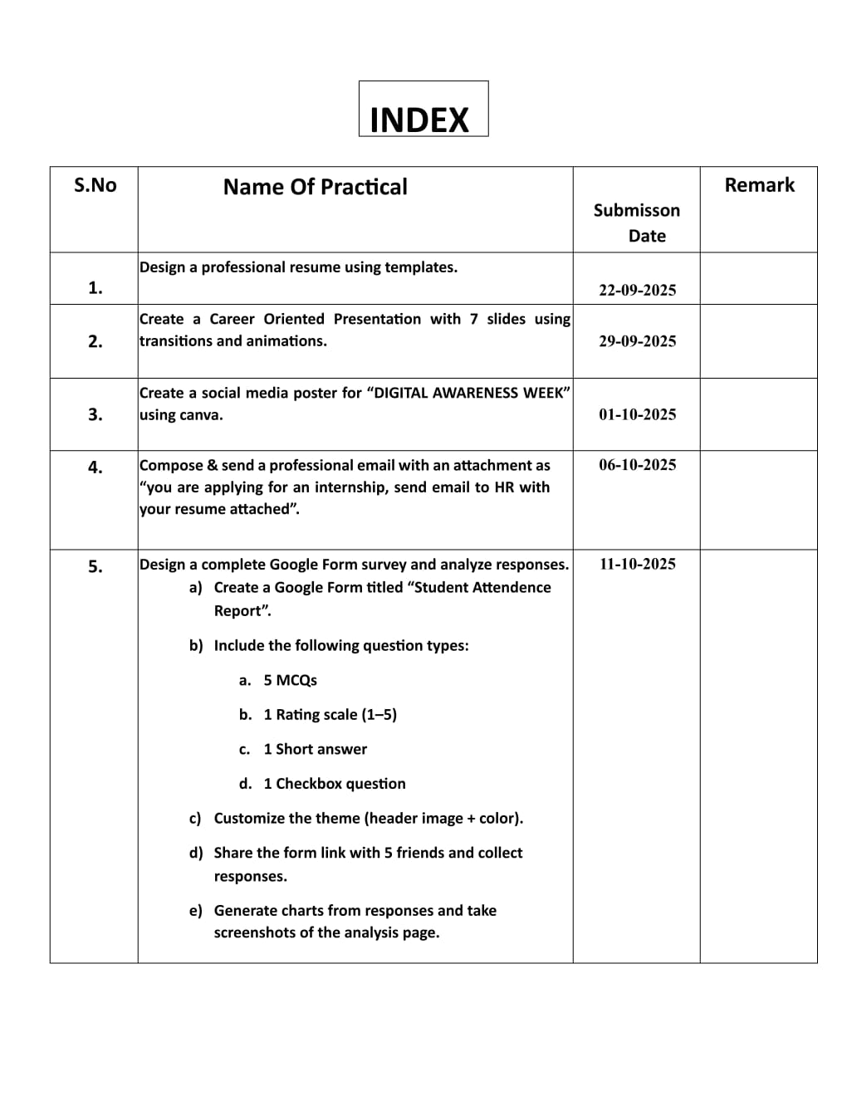

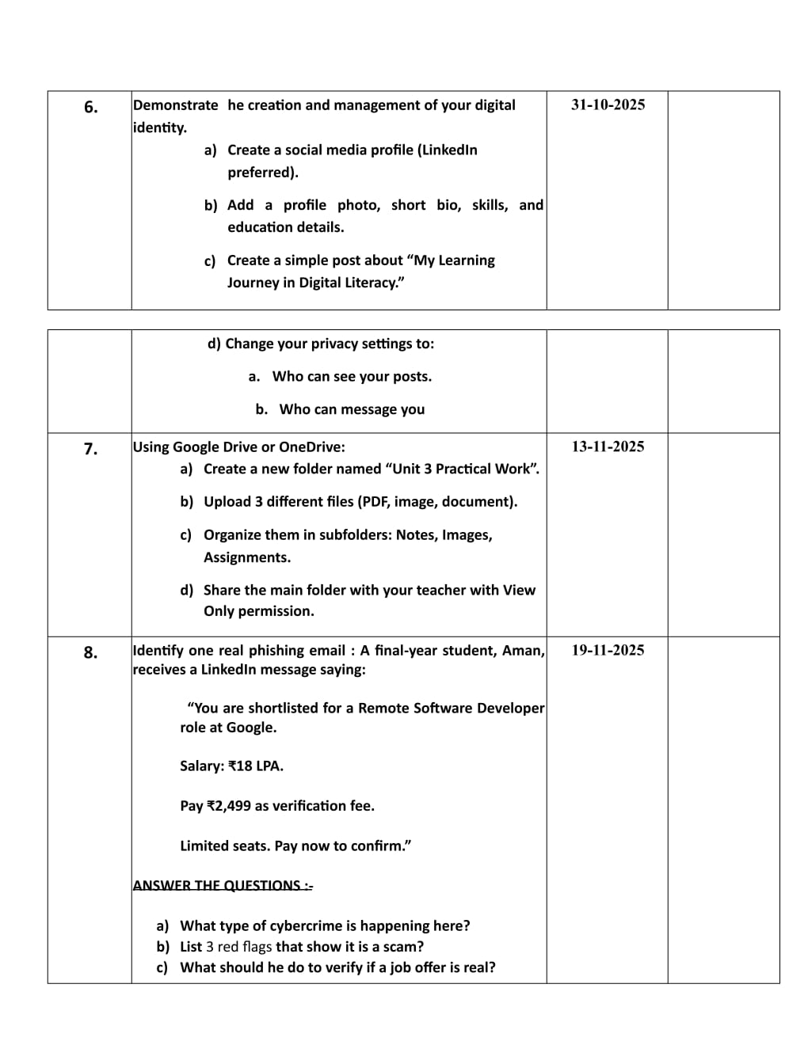

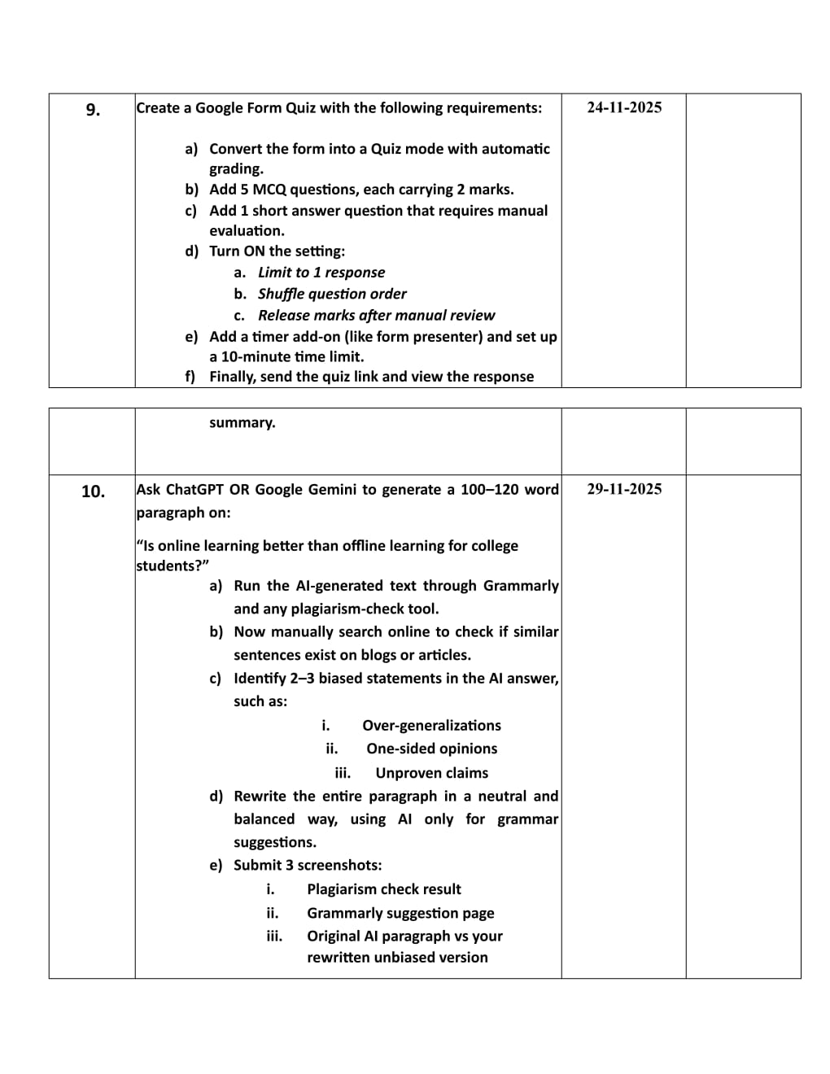

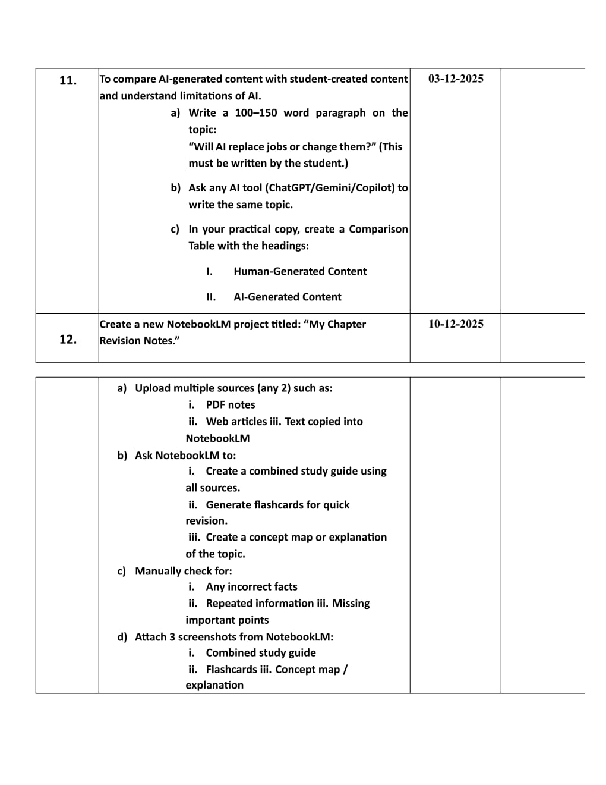

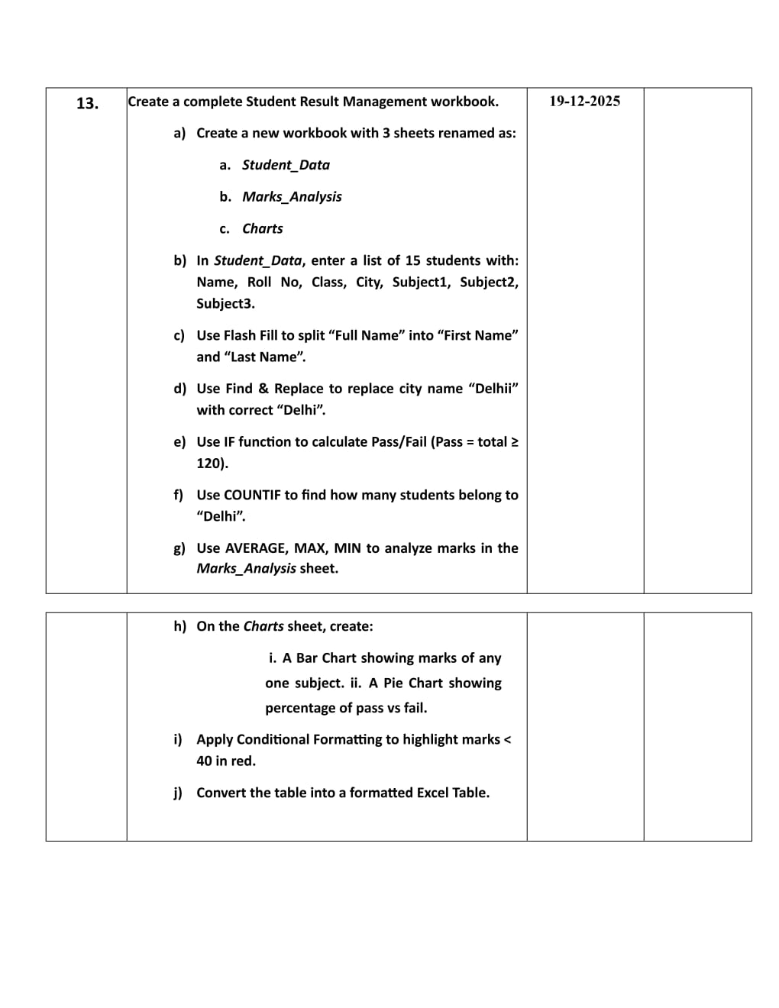

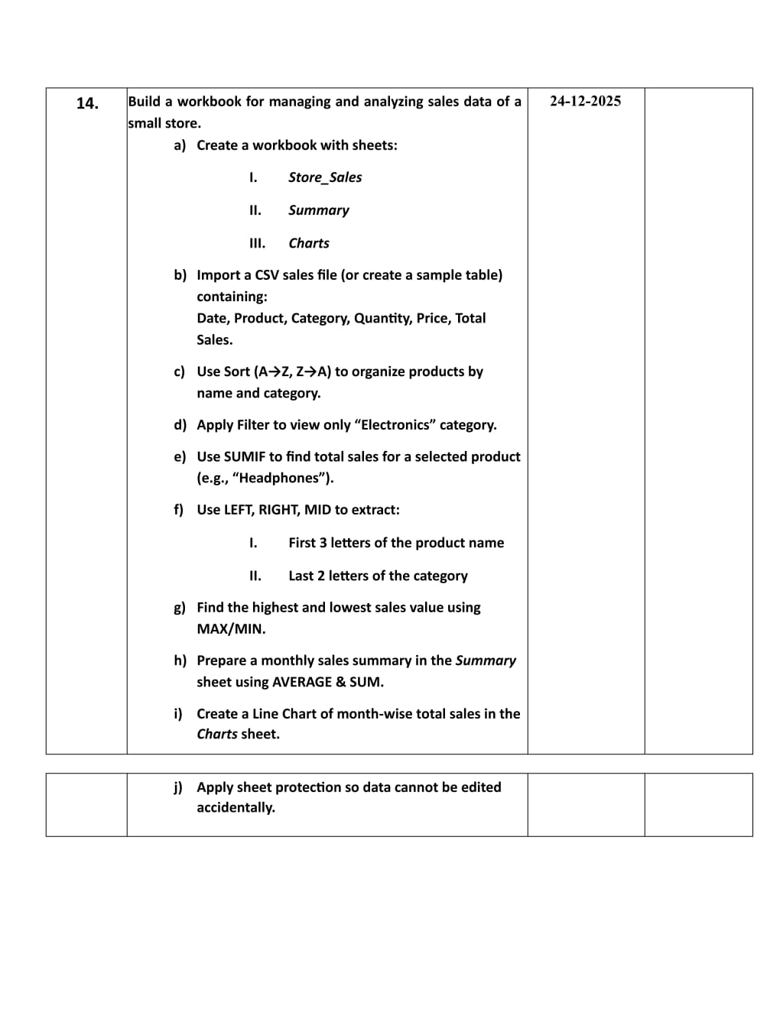

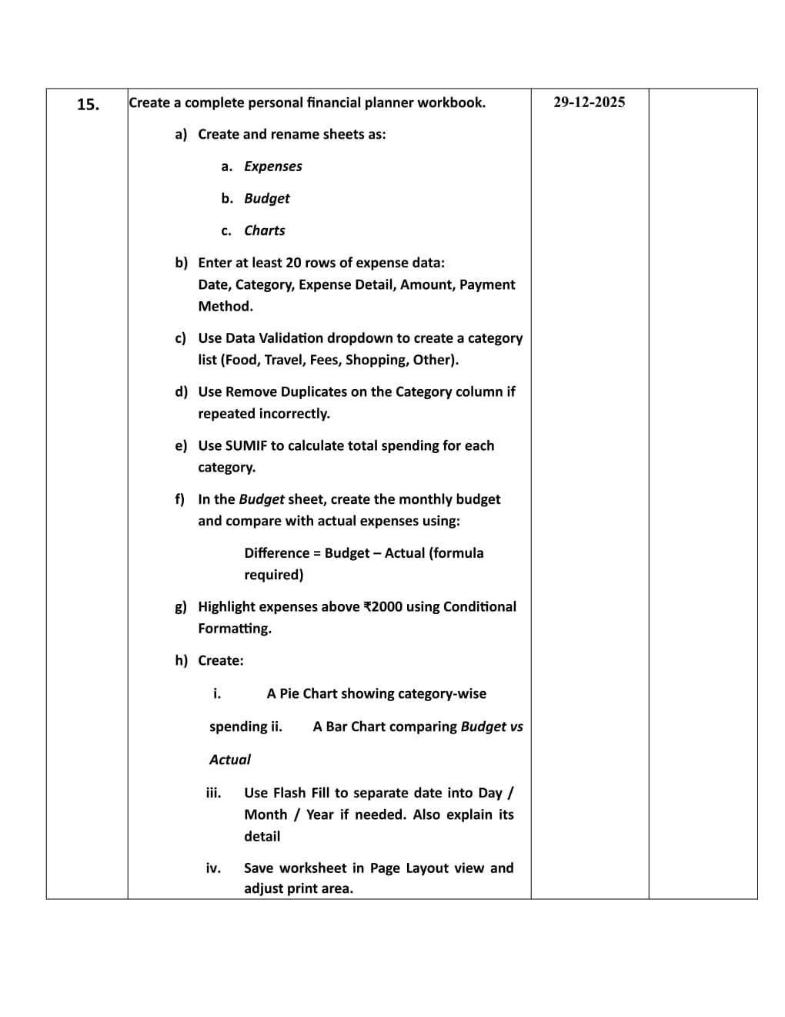

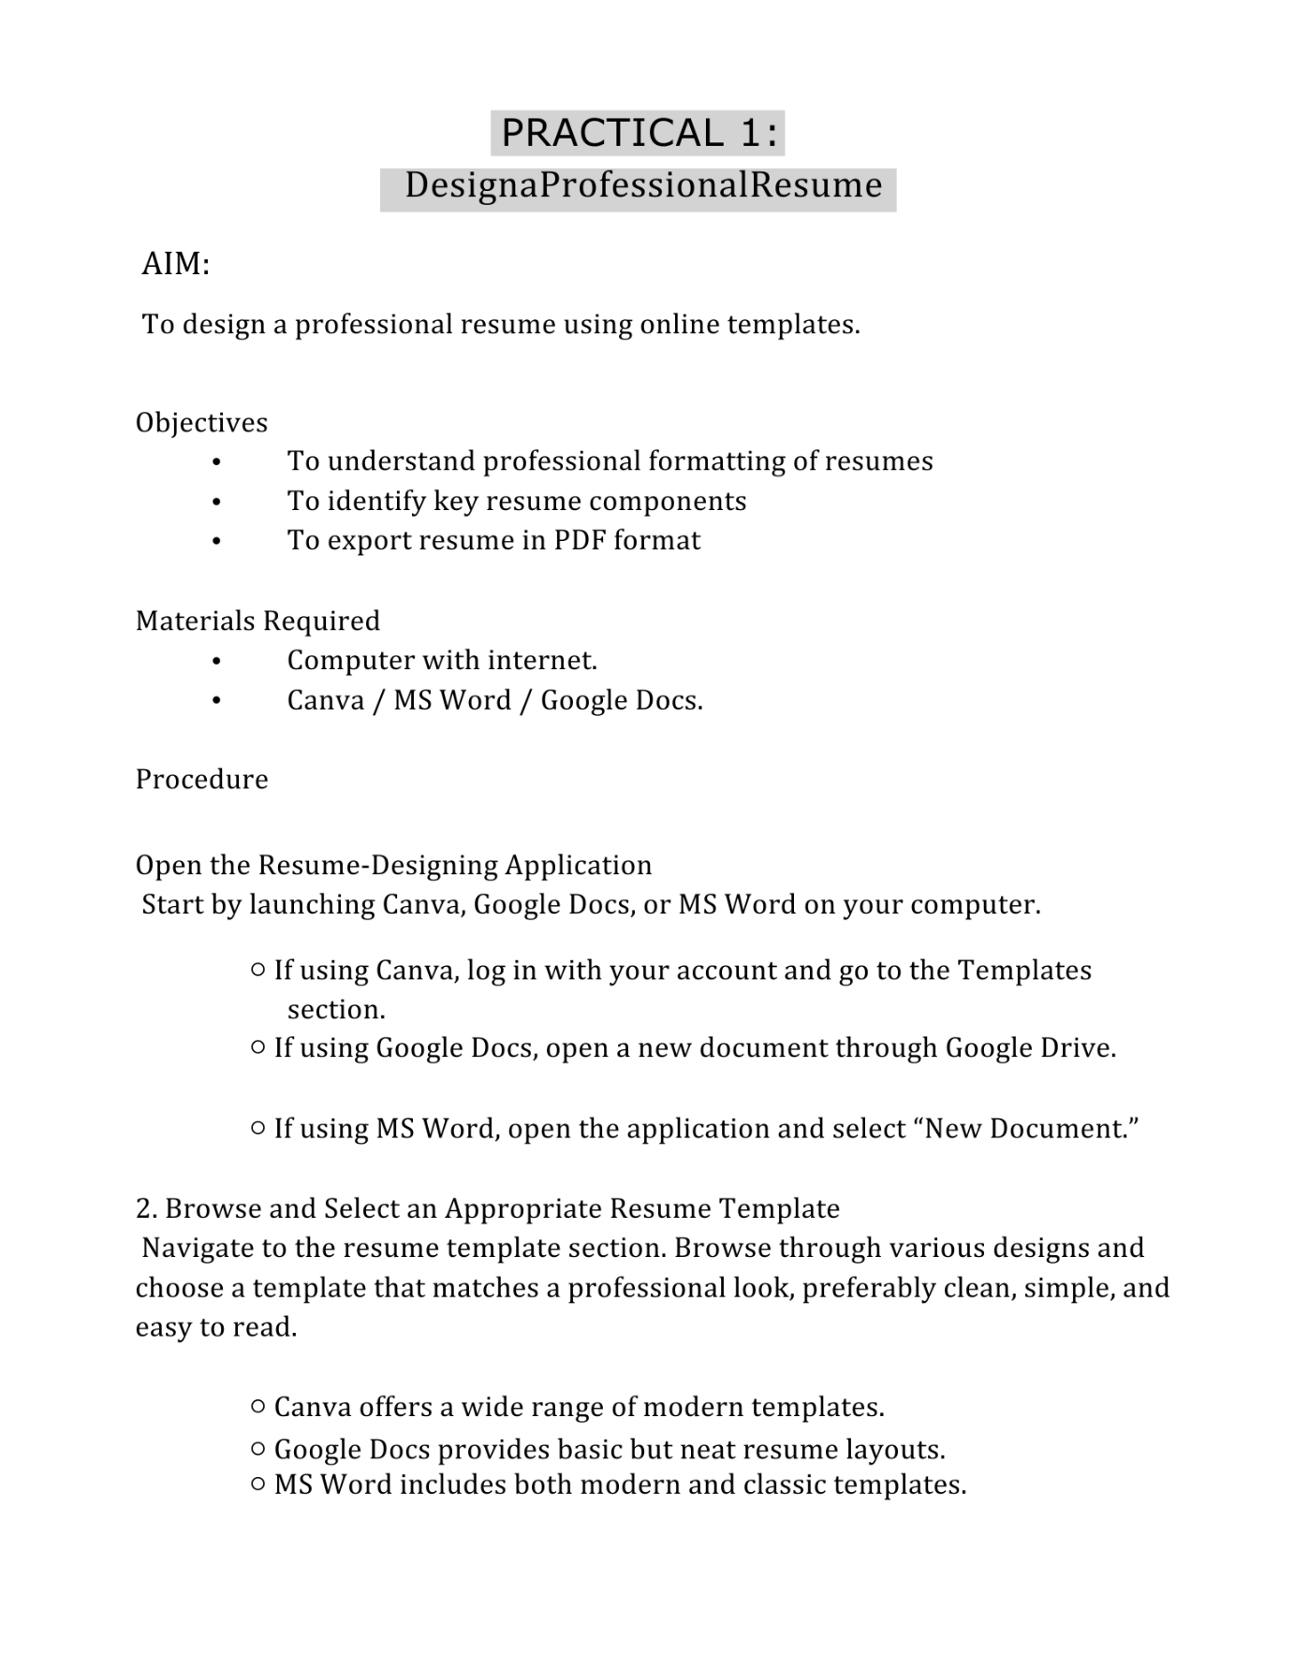

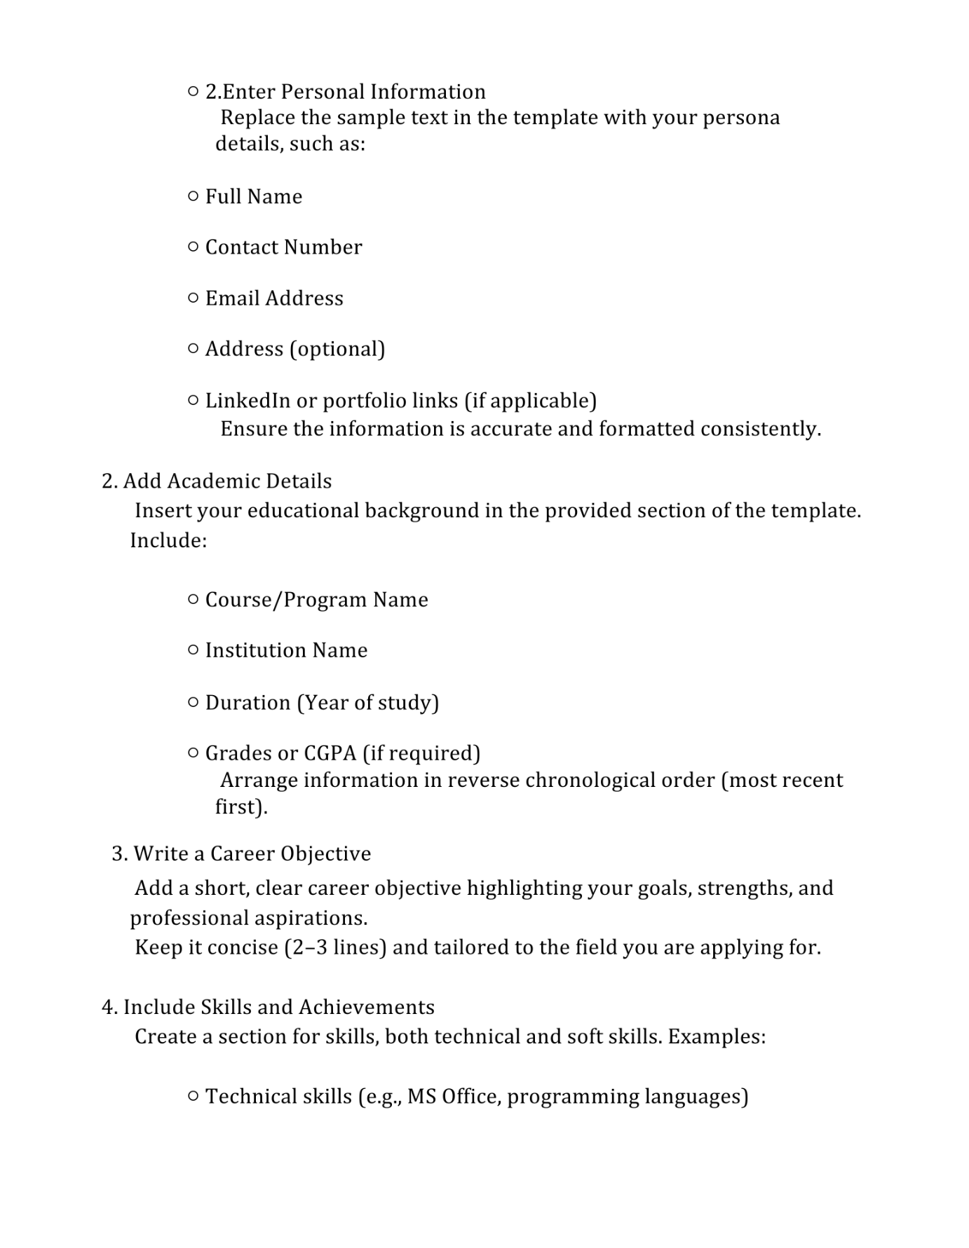

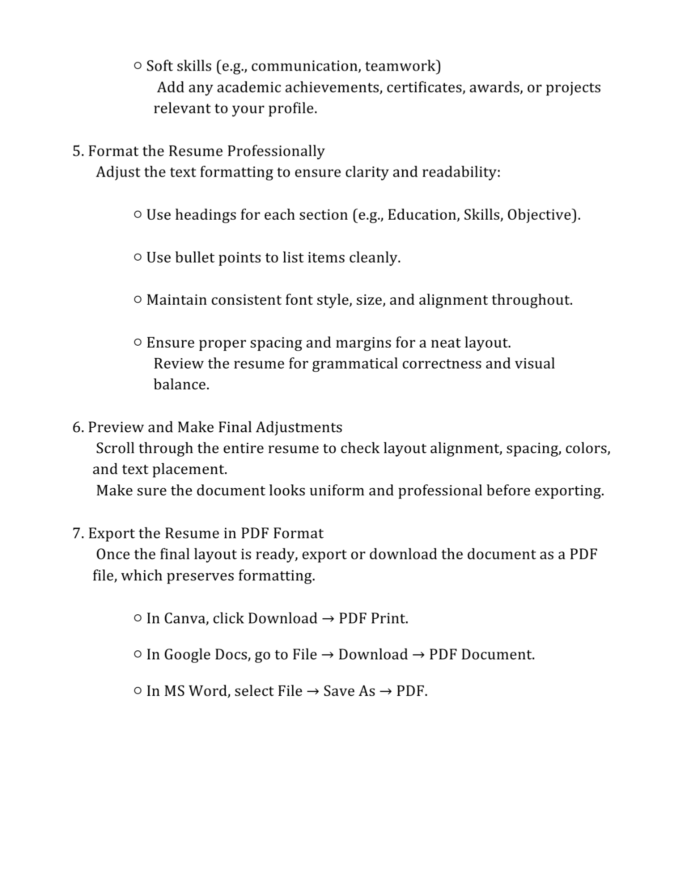

NEHA YADAV

ADDRESS: Plot no.03, Duggal Colony, Supela, Bhilai, C.G.

MOB: 9993186437

Email ID: neha.neha@rungta.org

Linkedin: https://www.linkedin.com/in/neha-yadav-9123b9392/

CAREER OBJECTIVES

A motivated and dedicated BCA (DATA SCIENCE) student seeking opportunities to enhance technical and professional skills. Eager to apply my knowledge in programming and problem-solving to contribute to organizational growth while continuously learning new technologies.

EDUCATION AND QUALIFICATION

Bachelor of Computer Applications (DATA SCIENCE)

Rungta International Skill University, Bhilai

2025 – Present

SKILLS

Technical Skills

C Programming

Python (Basic)

HTML

CSS

JavaScript

MS Office

Teamwork

Time Management

PROJECTS

Developed web applications using HTML, CSS, and JavaScript, including a Stone–Paper–Scissors game and a Simple Calculator.

Implemented interactive logic, user input handling, and real-time results.

Designed clean and responsive user interfaces.

Built a Railway Ticket Booking System in C with ticket booking, seat availability, and fare calculation features.

Practiced simple programming problems in C and Python

COURSES / CERTIFICATIONS

Pursuing BCA (DATA SCIENCE)

LANGUAGES

English

Hindi

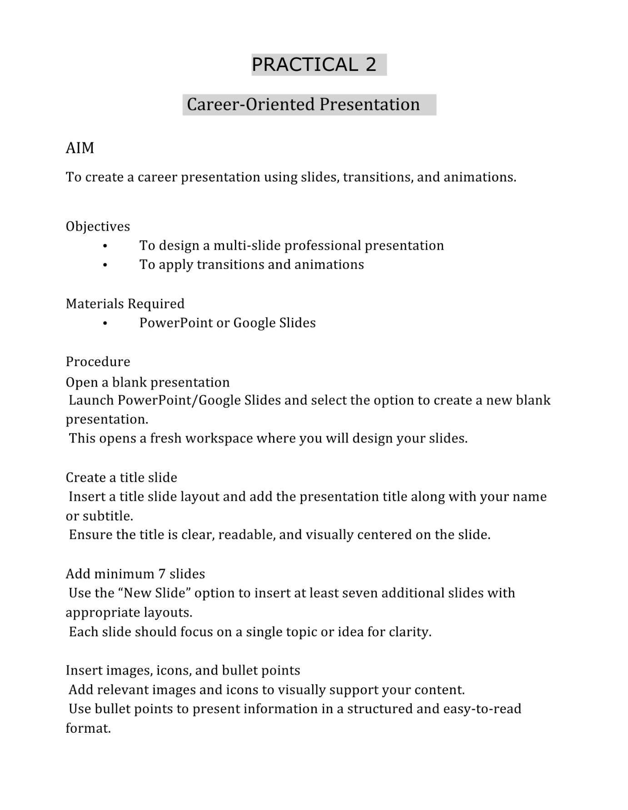





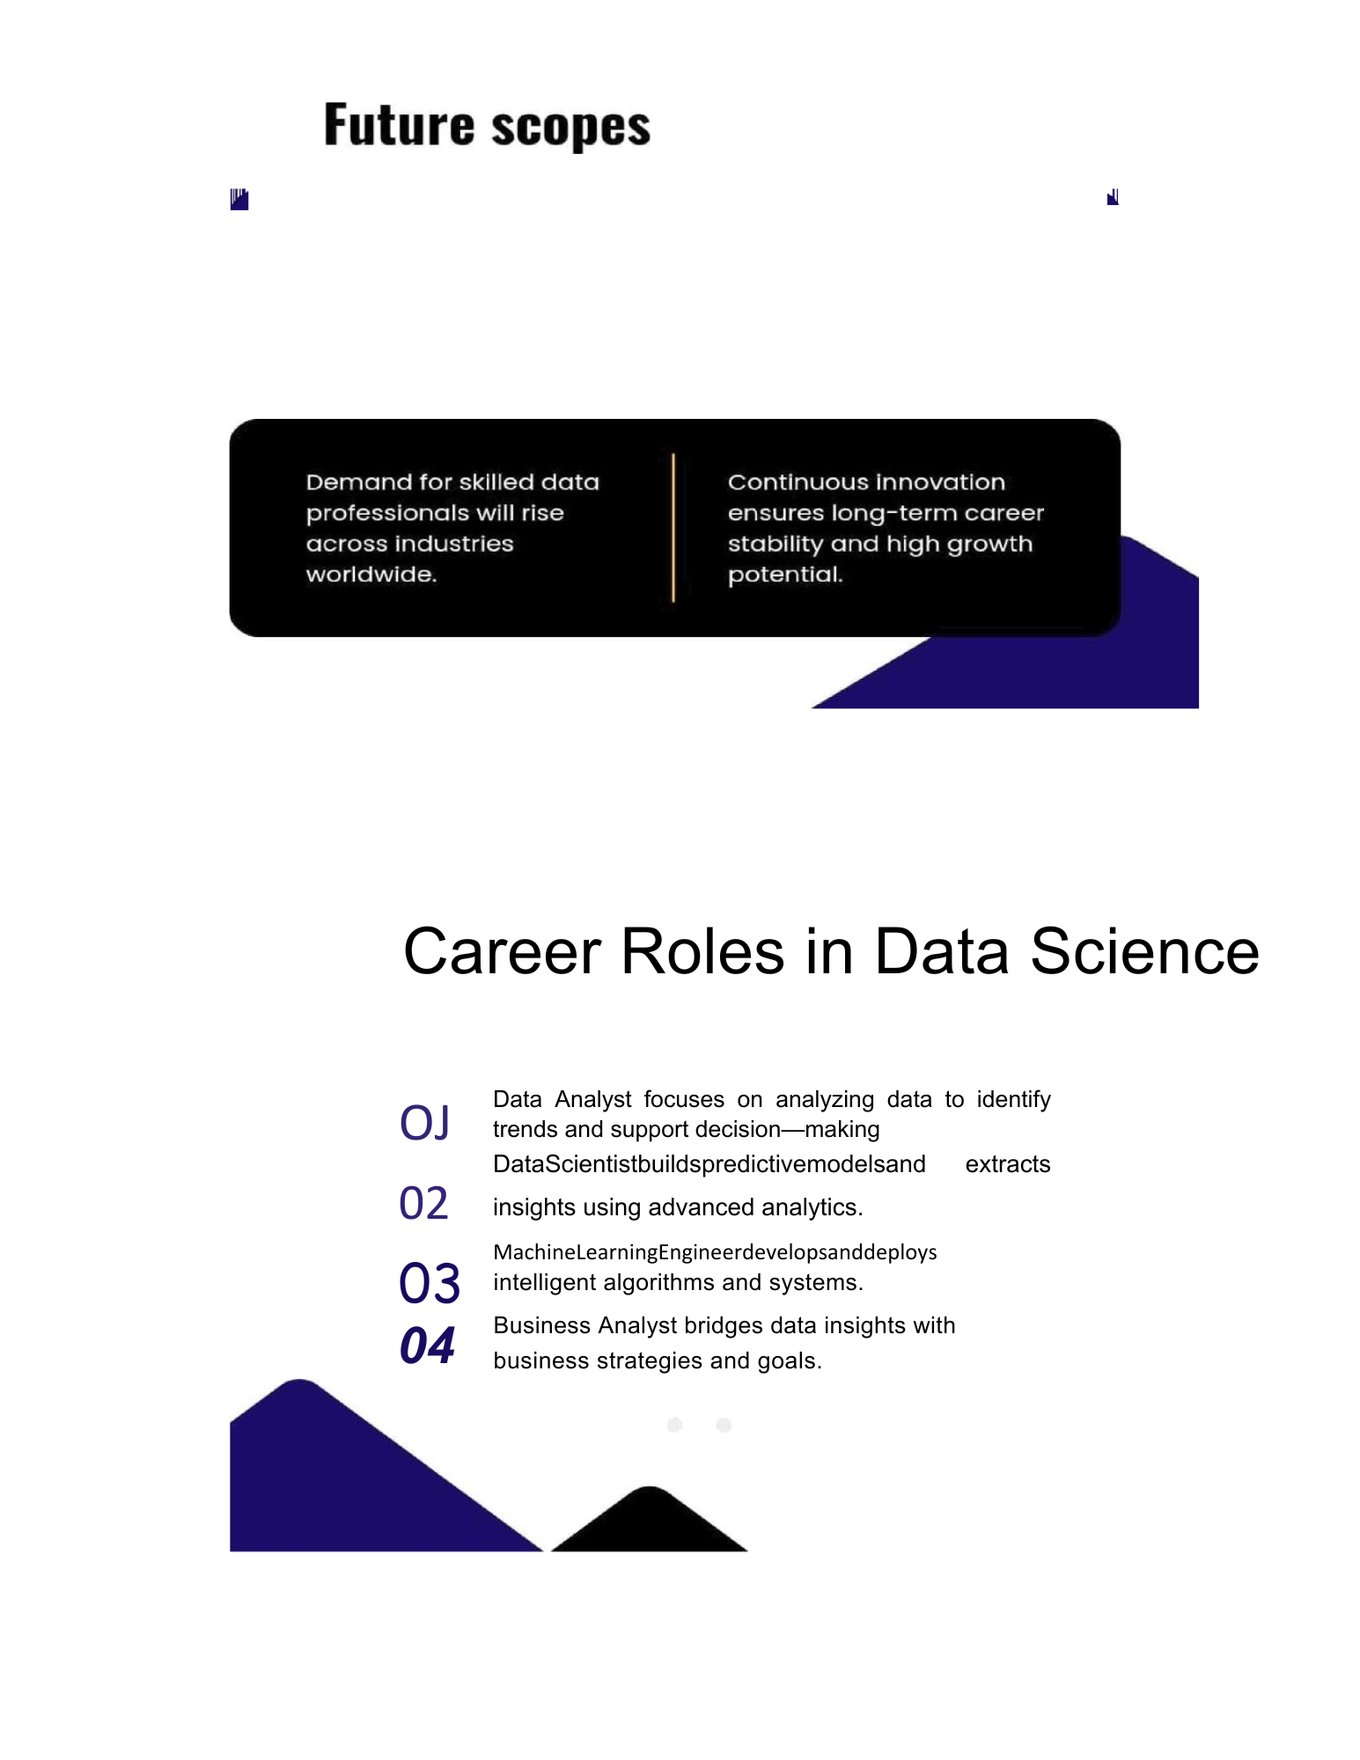

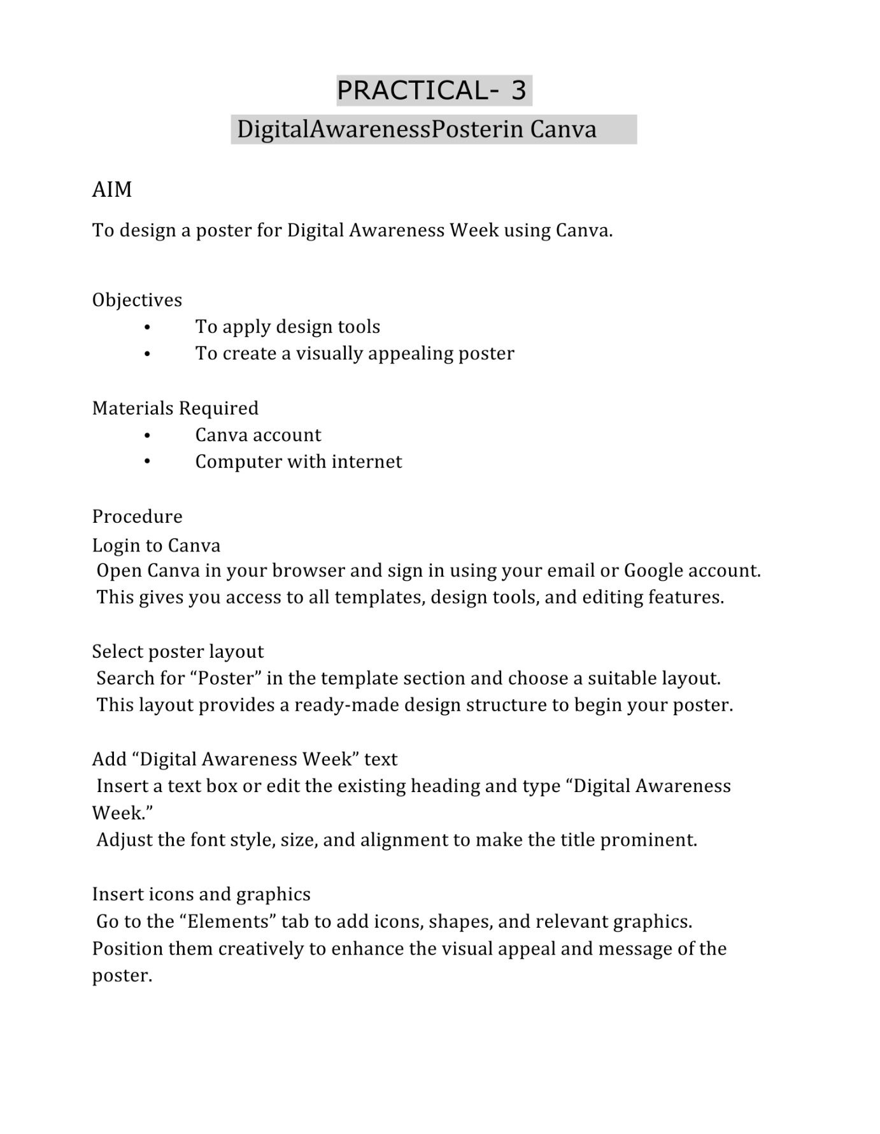

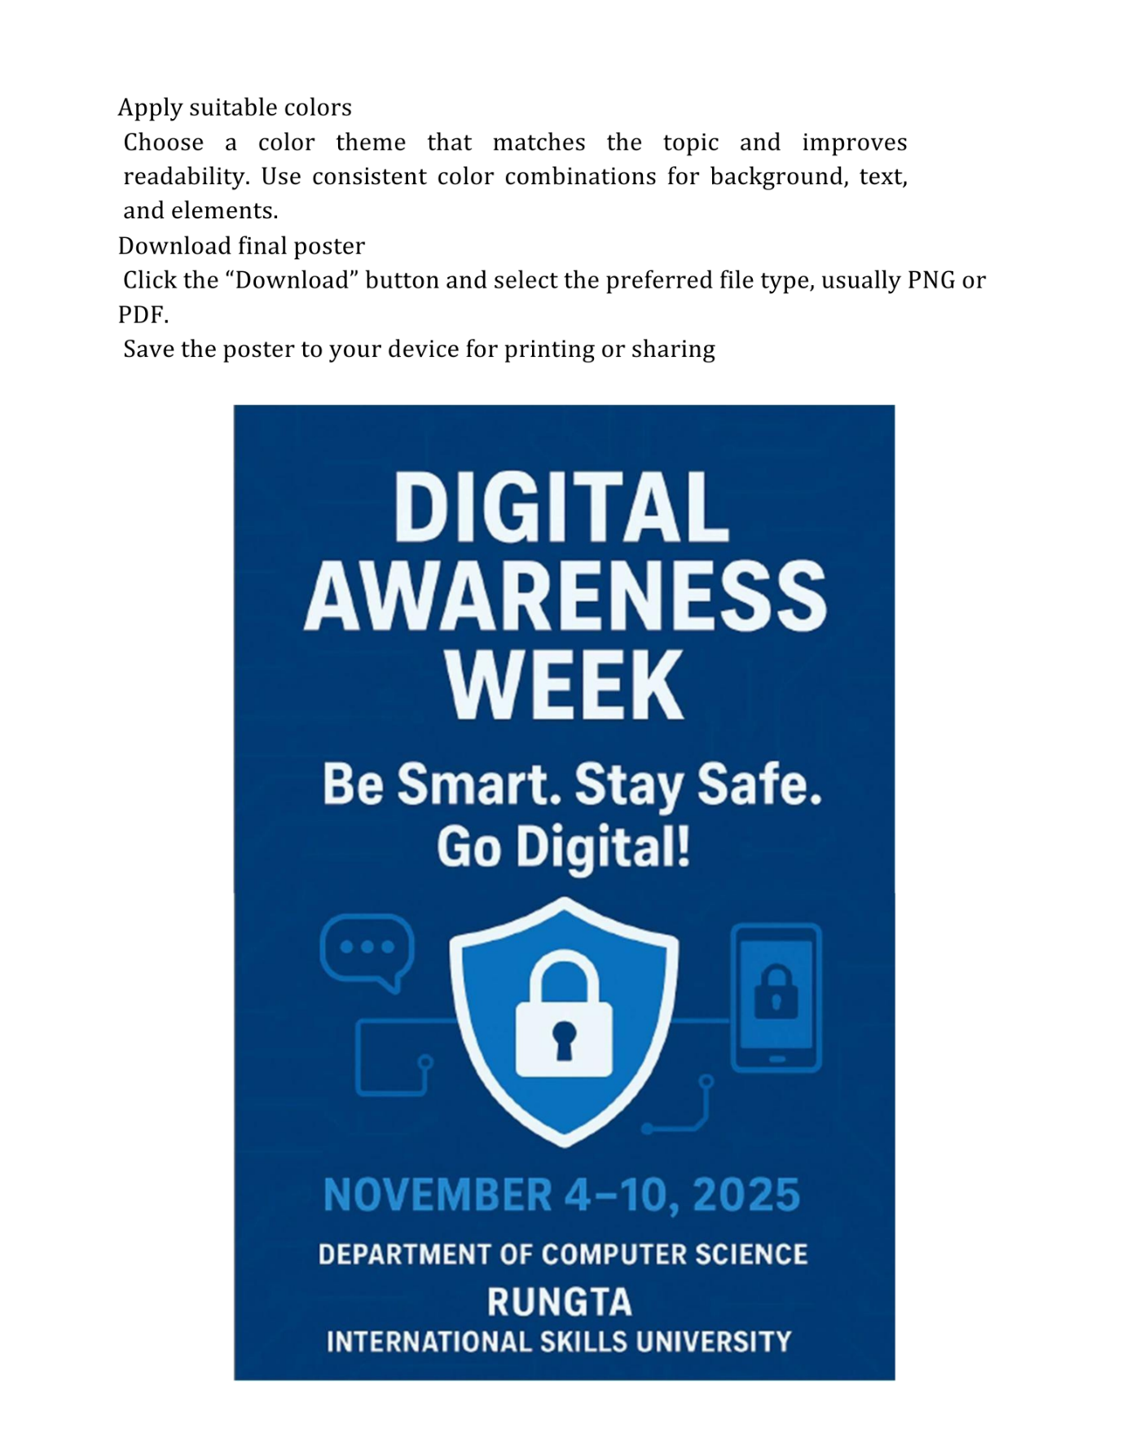



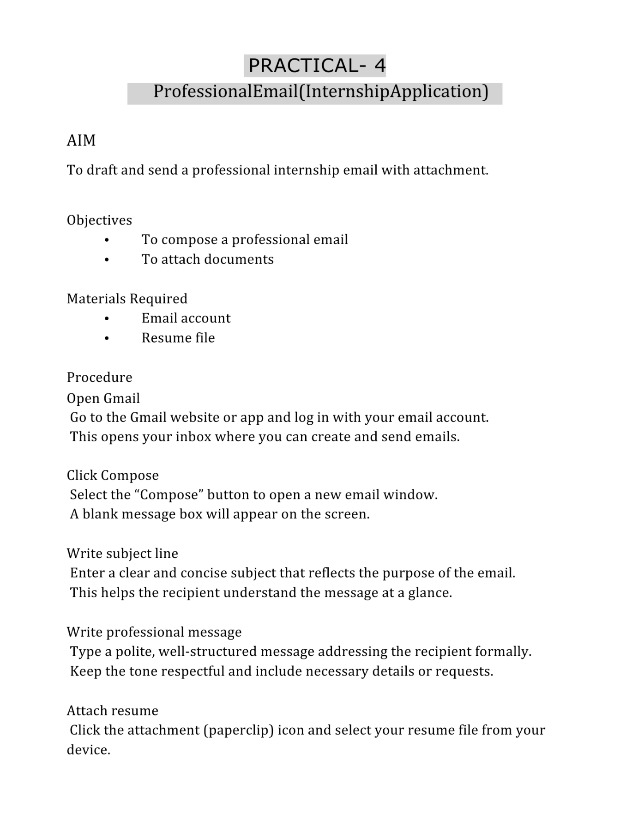

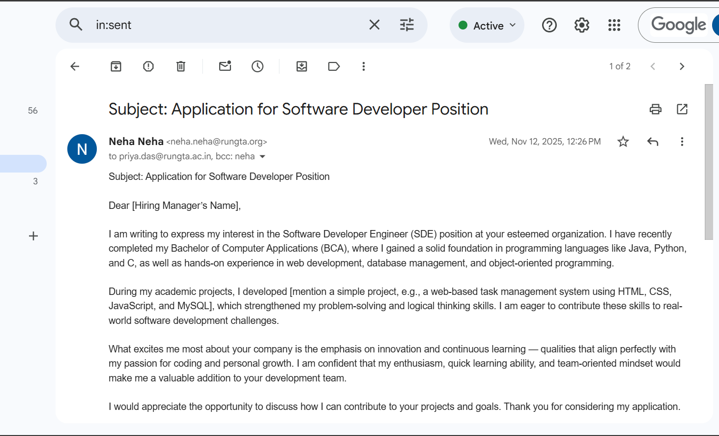

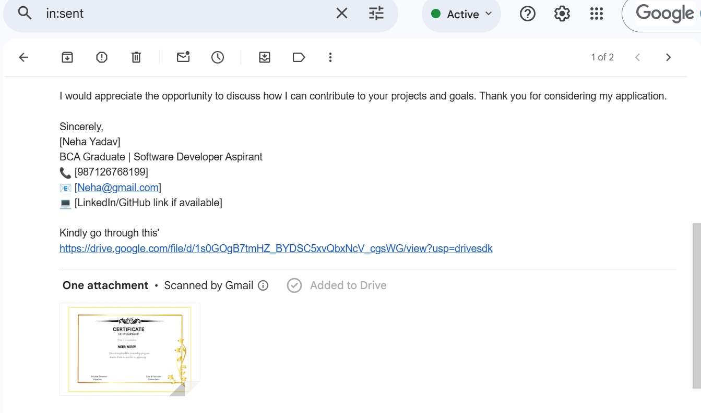

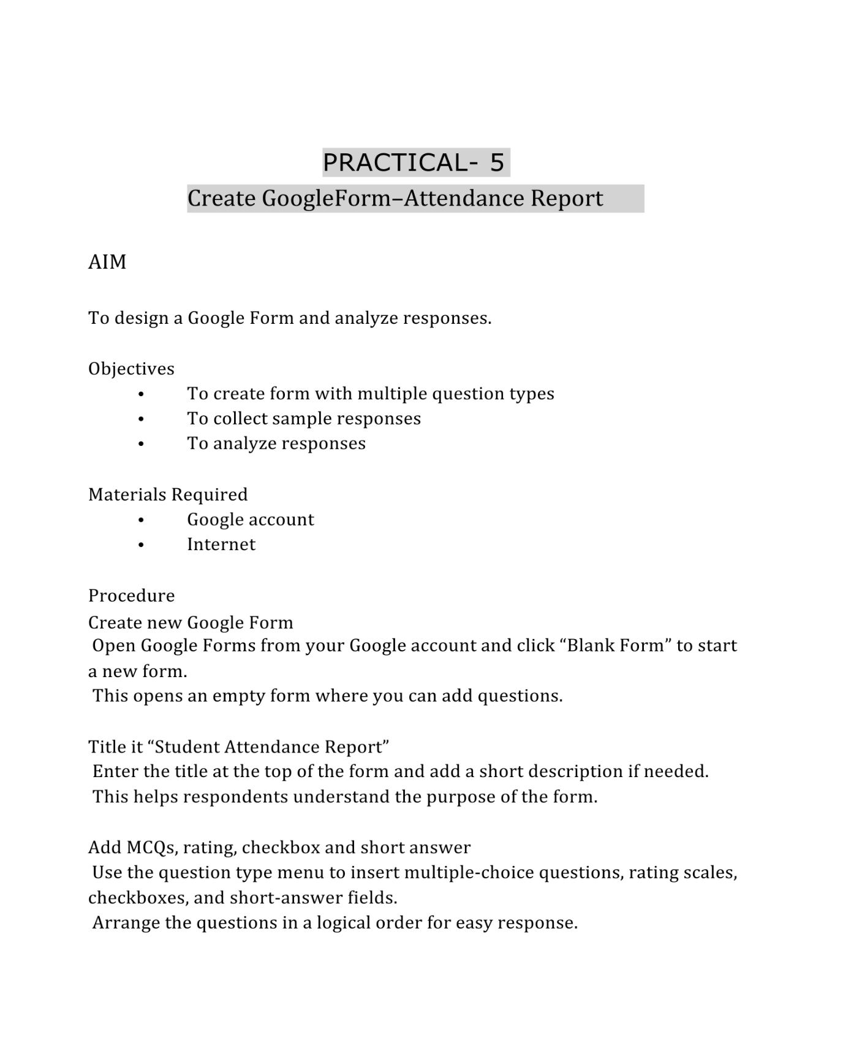

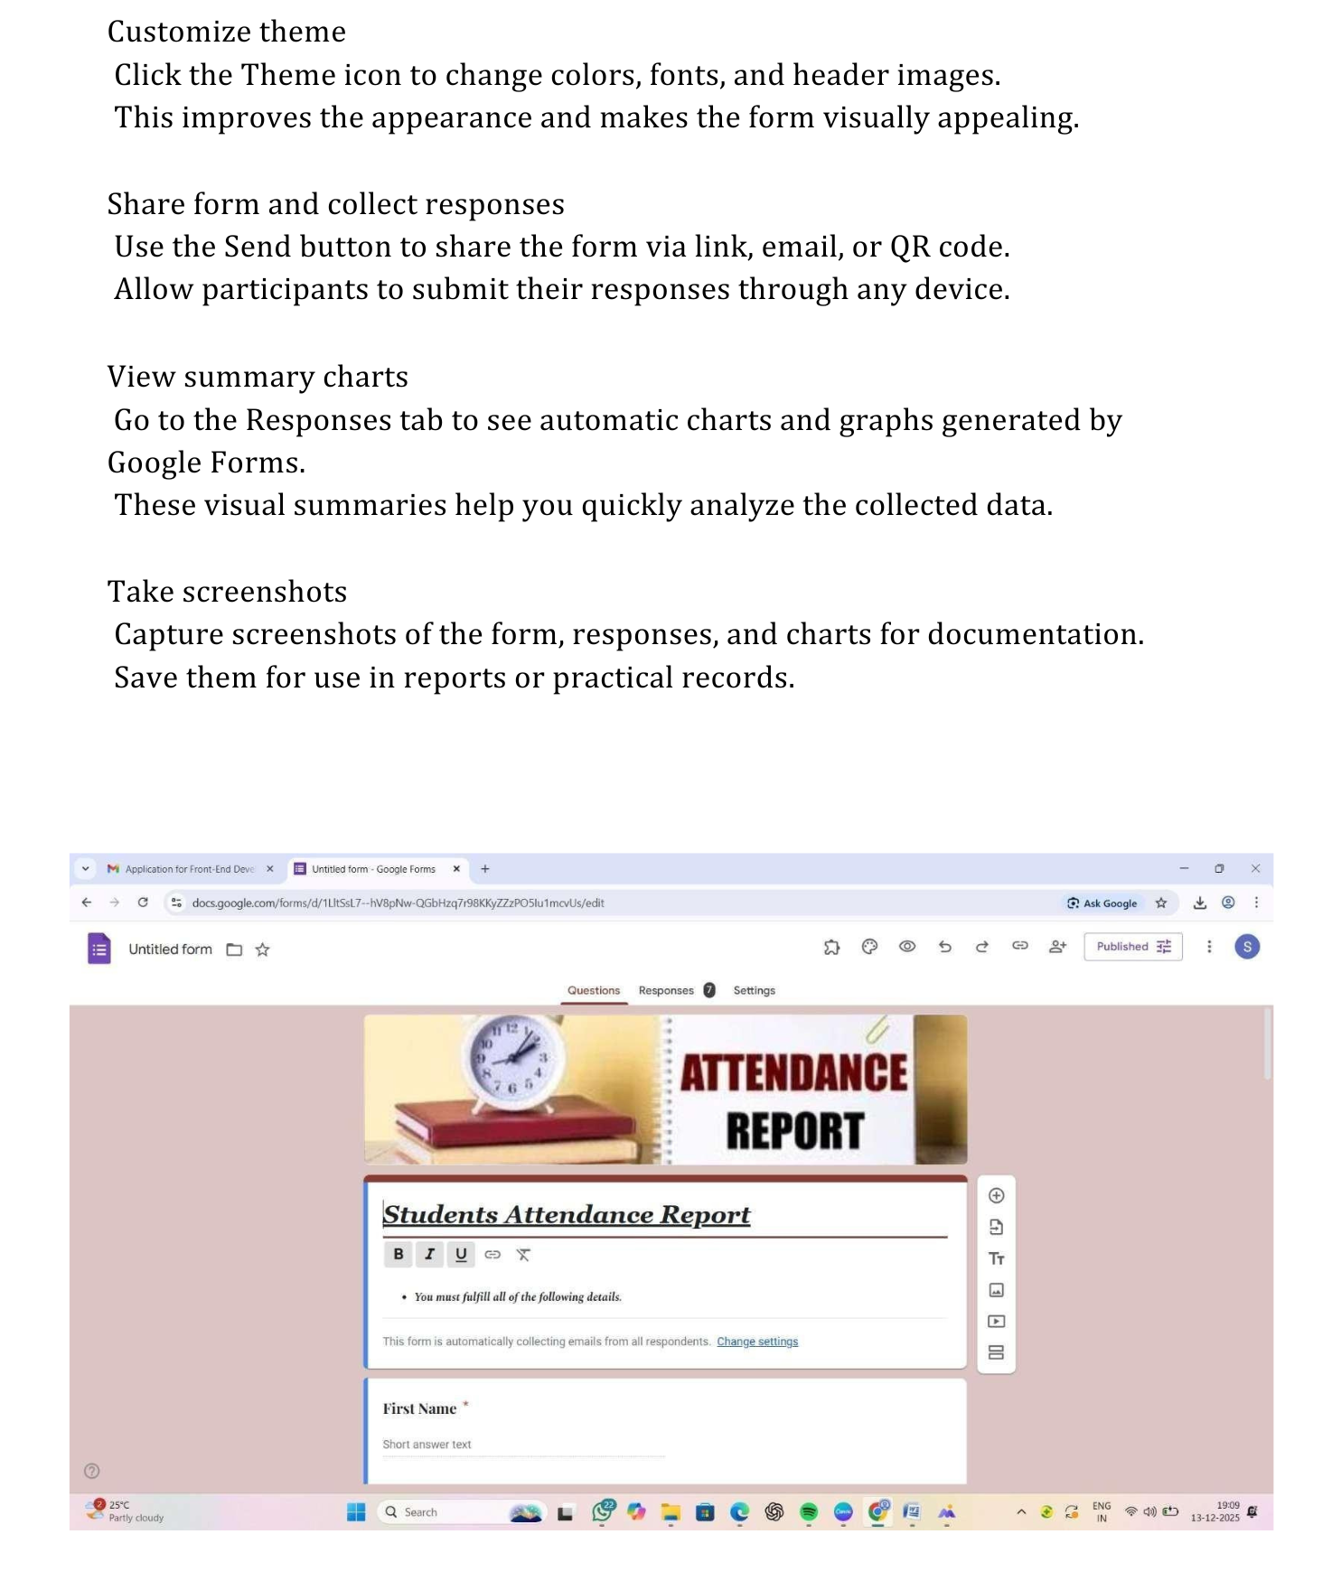

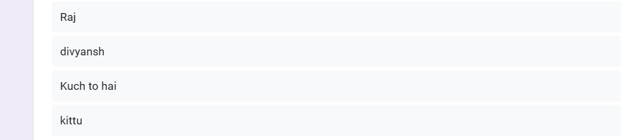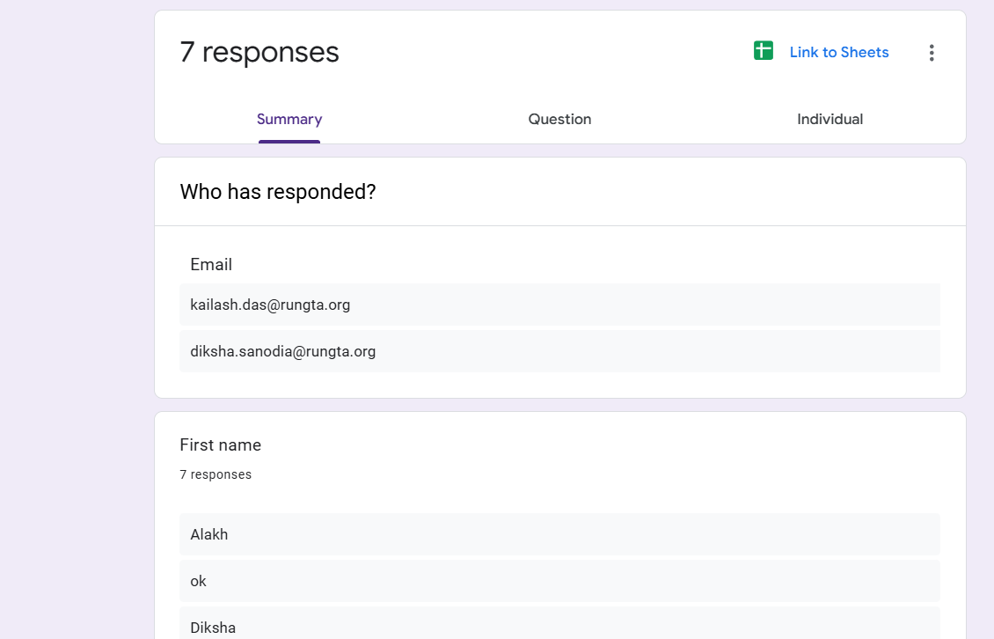

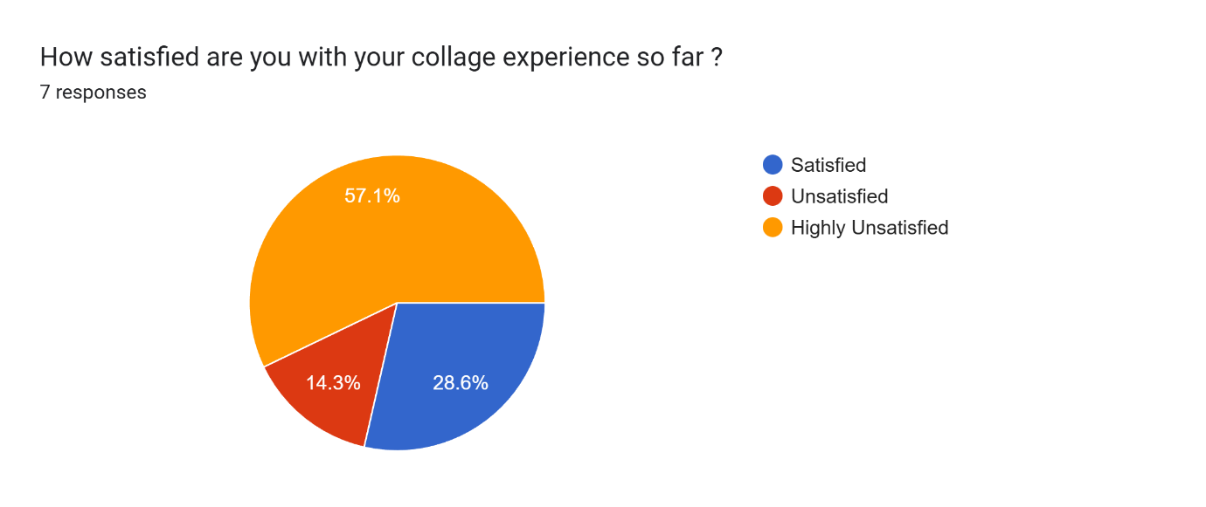

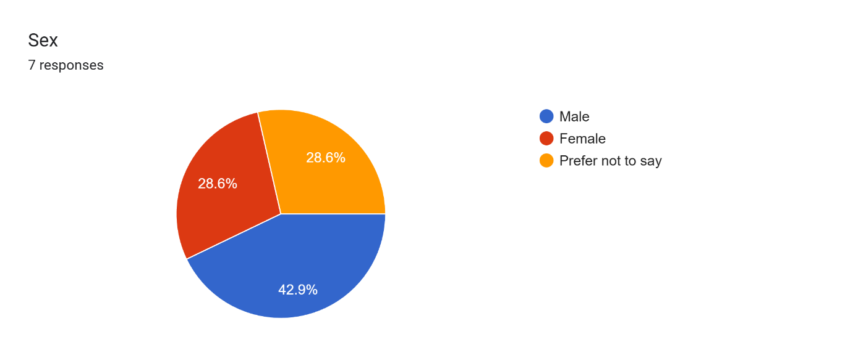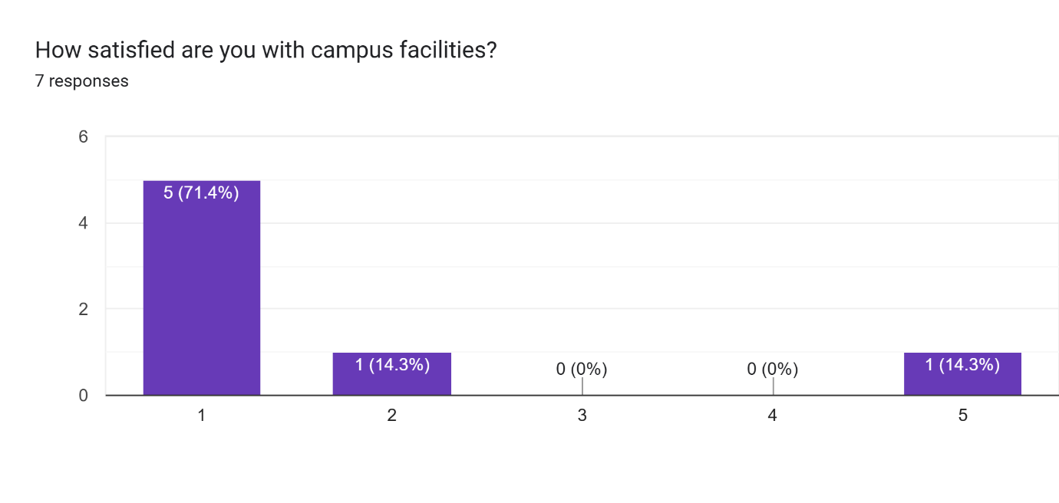

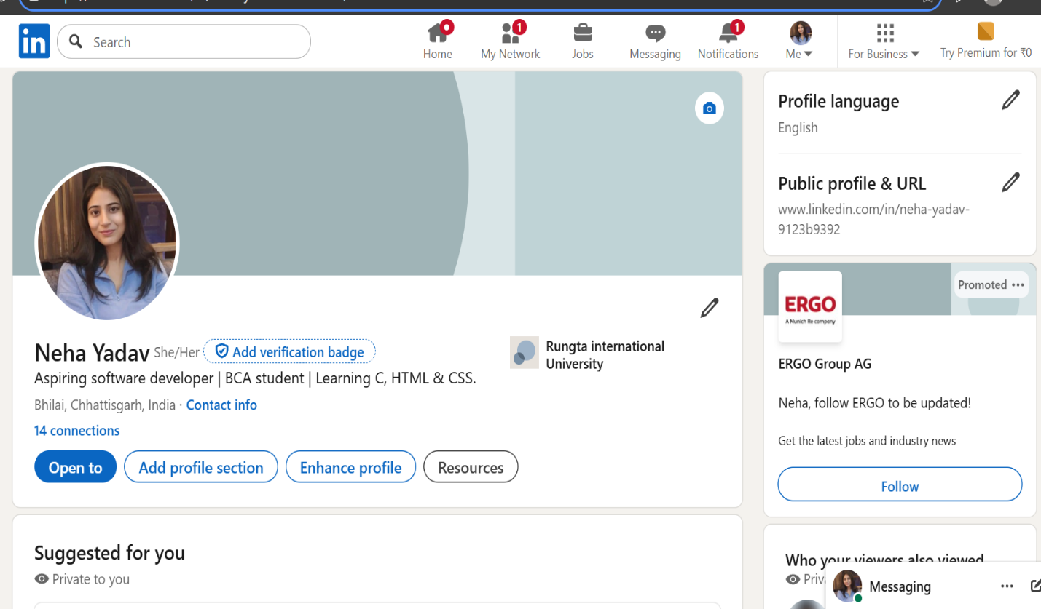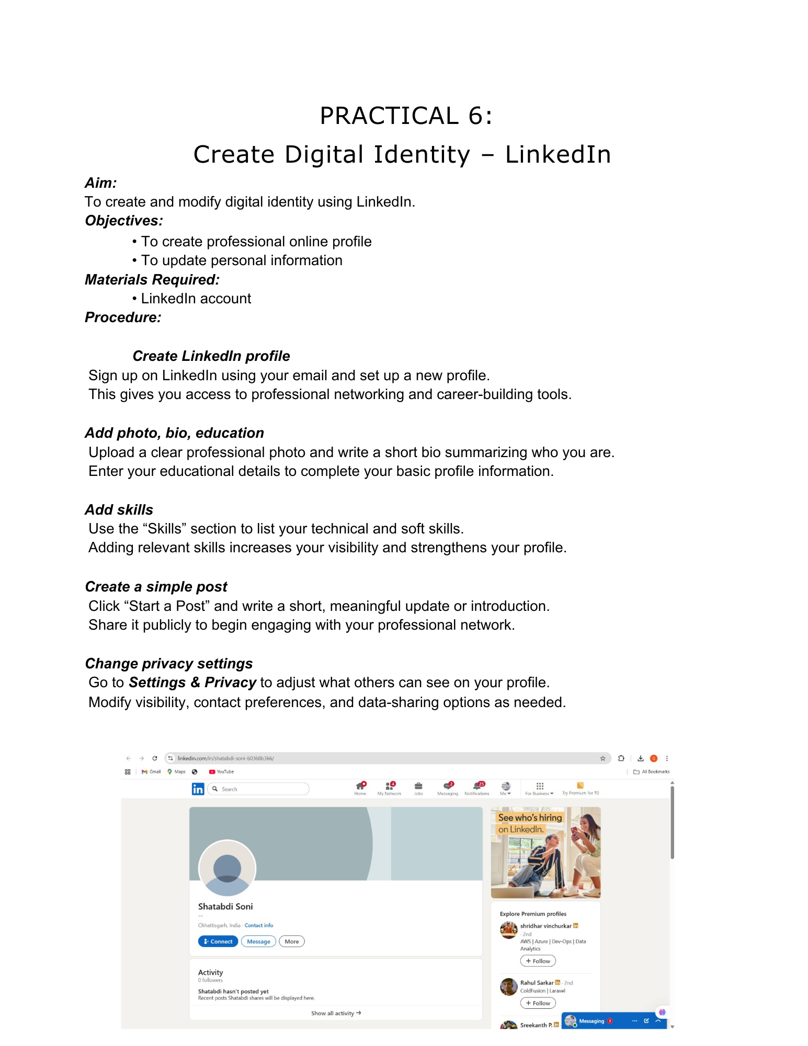

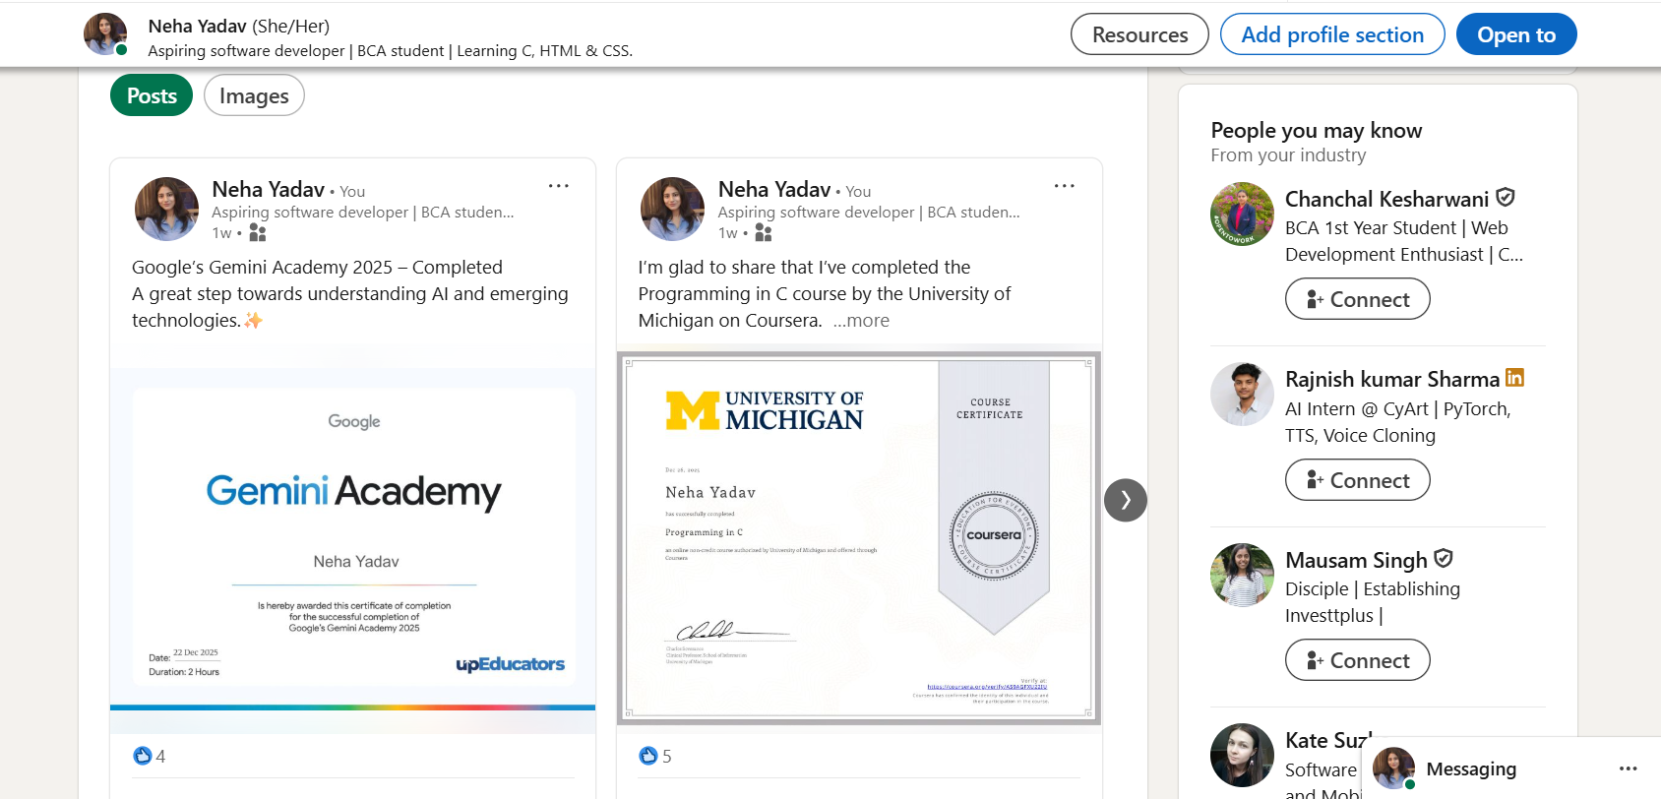

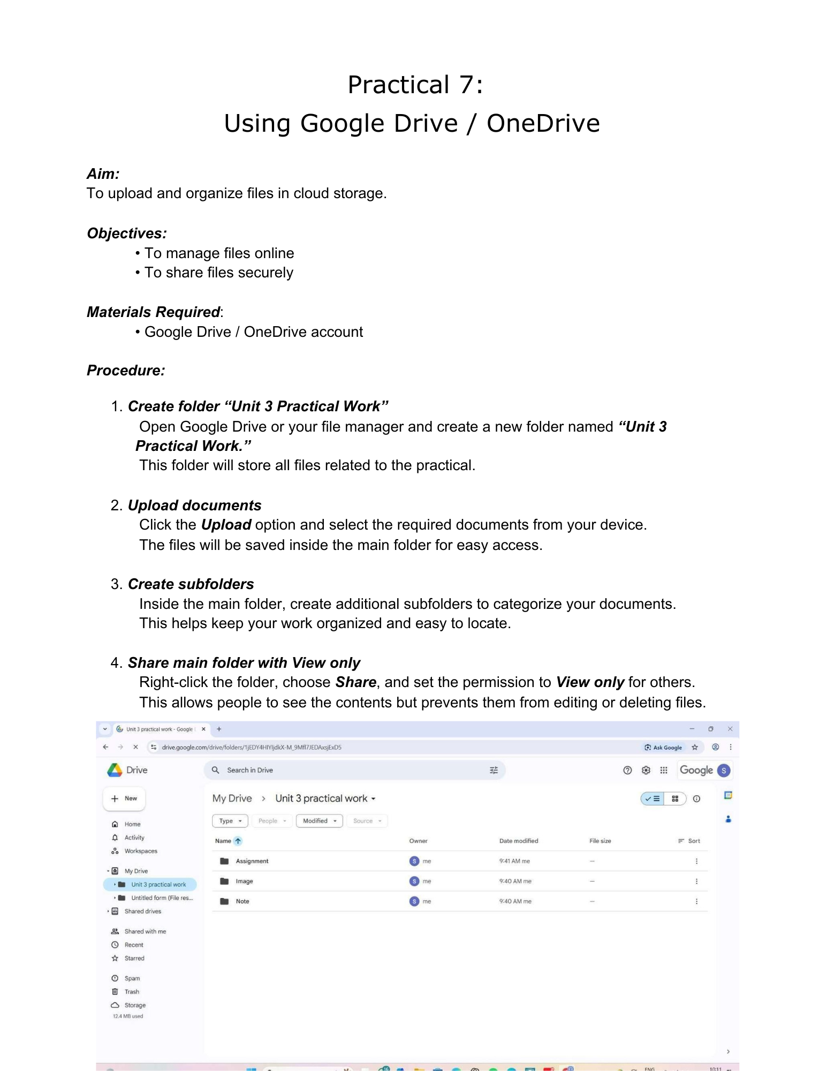

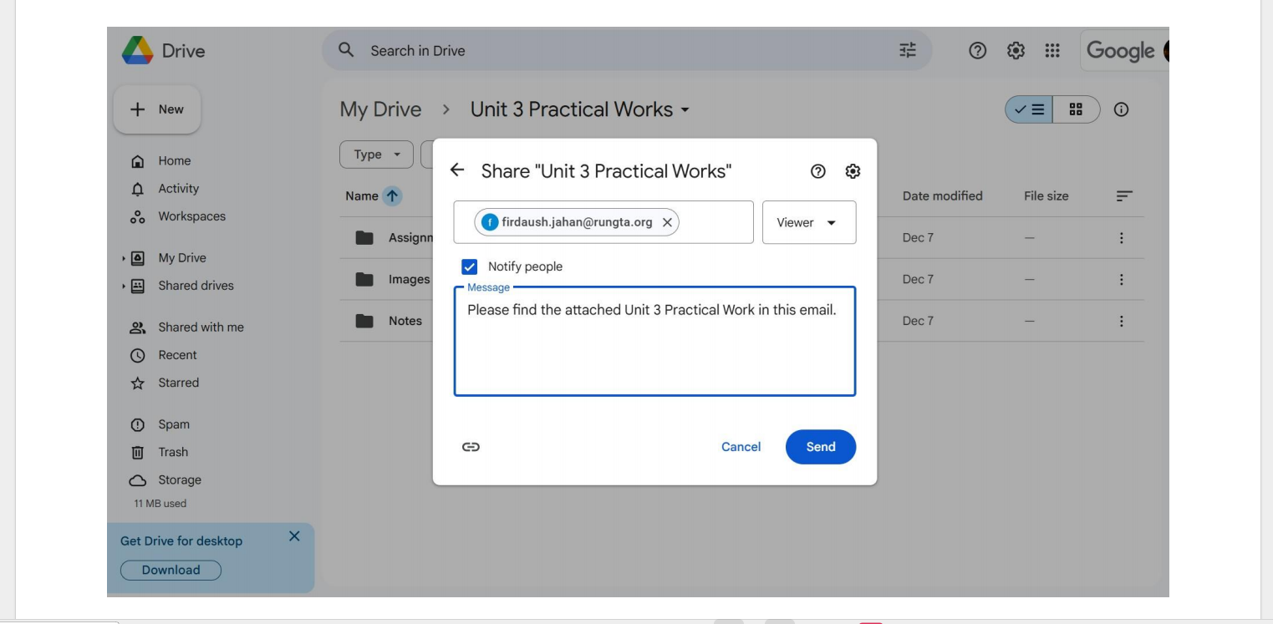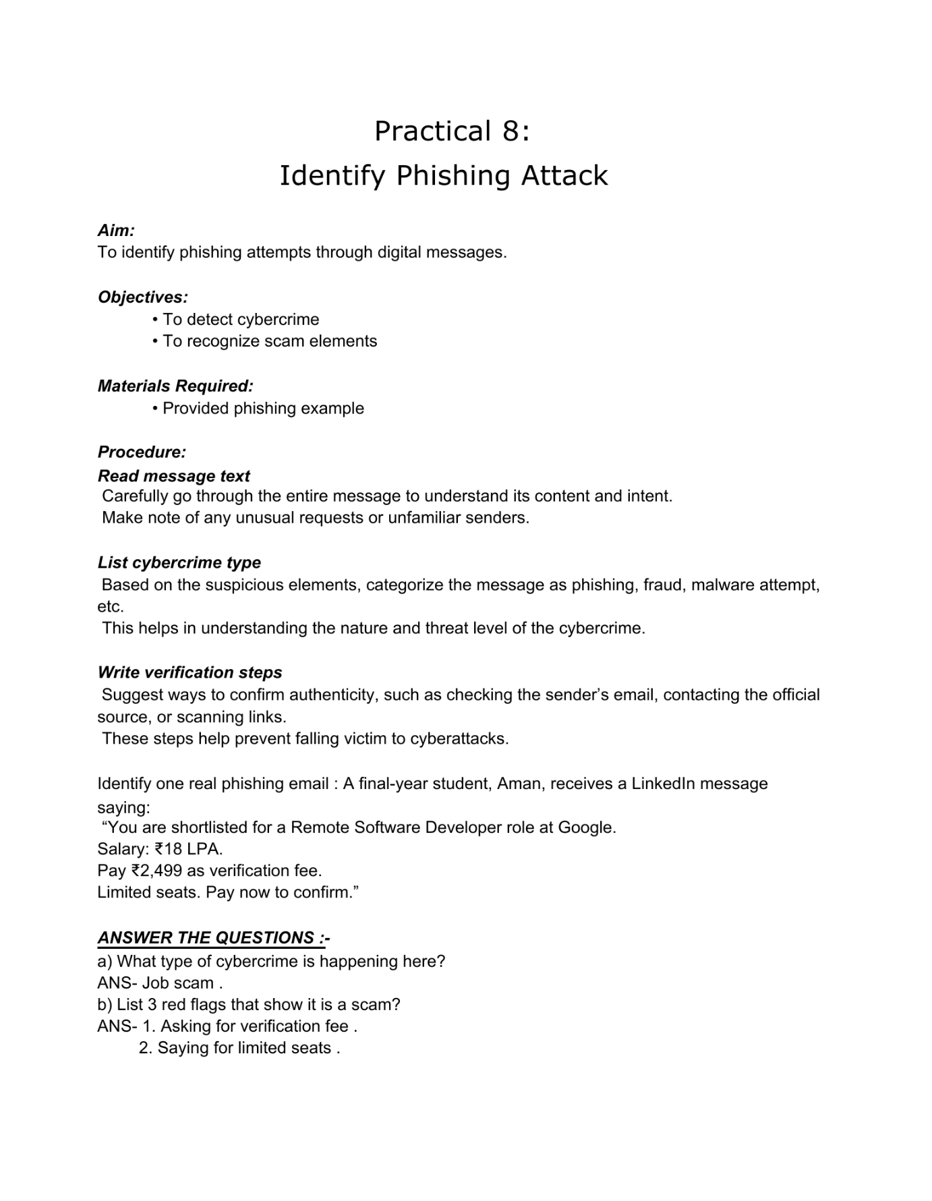



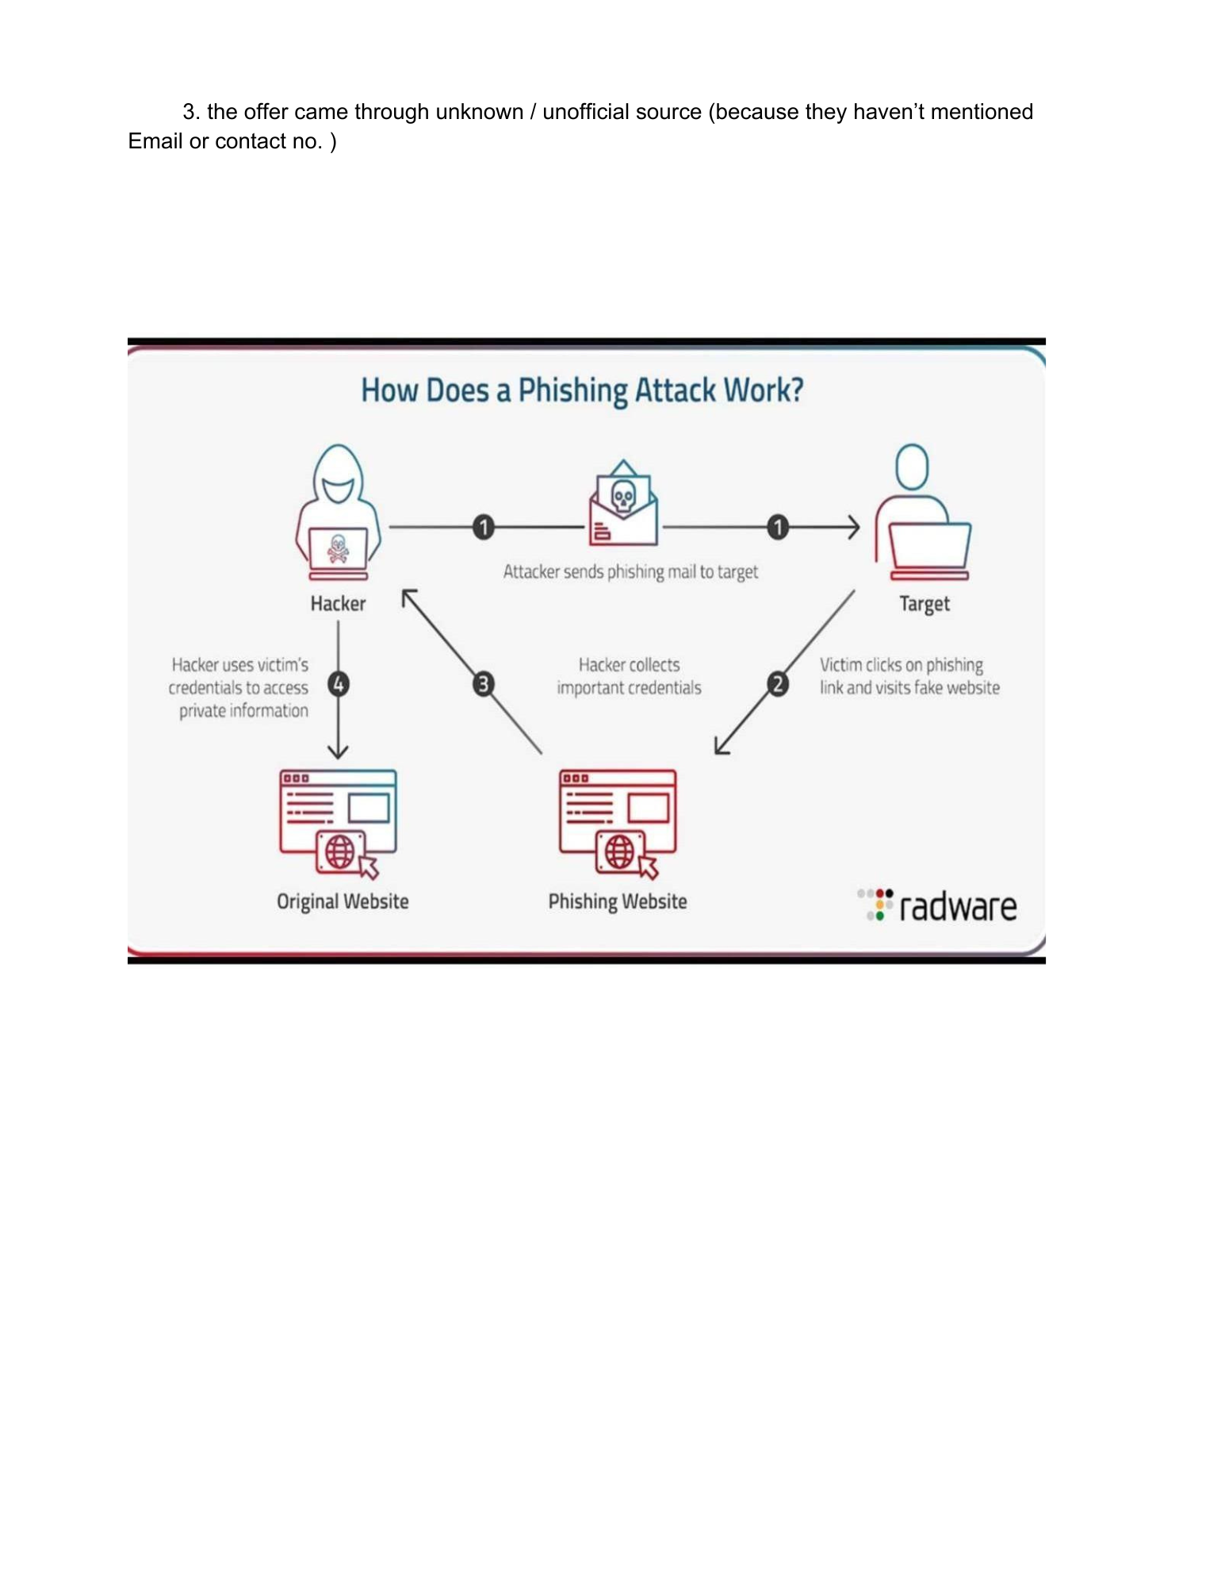

**Practical 9: Google Form Quiz with Timer**

**Aim**

To create a quiz with automatic grading and time limit.

**Objectives**

•

To automate quiz assessment

•

To use time limit add-on

**Materials Required**

•

Google Forms

•

Timer add-on

**Procedure:-**

1. Create Google Form – Open Google Forms and start a new blank form to set up

the structure of your activity.

2. Convert to quiz – Enable “Make this a quiz” in the settings so you can assign points

and correct answers.

3. Add 5 MCQs + 1 short answer – Insert five multiple-choice questions and one short

answer question, customizing options and points.

4. Enable 1-response limit – Turn on “Limit to 1 response” so each user can submit the

form only once.

5. Shuffle questions – Activate the shuffle feature to randomize the order of questions

for every respondent.

6. Add timer add-on – Install a timer add-on from the Add-ons menu to set and control

the quiz duration.

7. Send link – Use the “Send” button to generate and share the form link with participants.

